Unit 3: The Age of Absolutism

Concept Connector – How have societies chosen to govern themselves?

A society is a complex network of relationships among individuals and groups whose goals may clash. To avoid chaos, societies create governments to make decisions in the common interest. They also create governments to defend themselves from attack. Throughout history those governments, or political systems, have taken many forms, depending on historical circumstances. The ancient Greeks designated three types of government: rule by one (monarchy, autocracy); rule by the few (aristocracy, oligarchy); and rule by the many (democracy). Consider the following historical examples:

Rule by One
- The ancient Egyptians needed an efficient government to manage activities related to the annual flooding of the Nile. At the head of the government stood an absolute monarch, the pharaoh. The pharaoh relied on his vizier, or chief minister, to handle the country’s affairs. The vizier directed a large government bureaucracy. Most Egyptians had no say in how they were governed.
- As chairman of the Communist Party, Mao Zedong ruled China from 1949 until his death in 1976. In reality he stood above the party as an autocrat with dictatorial powers. At will, he purged party members and military leaders who crossed him. Through the party, he maintained tight control over the government, economy, and most other aspects of Chinese society.
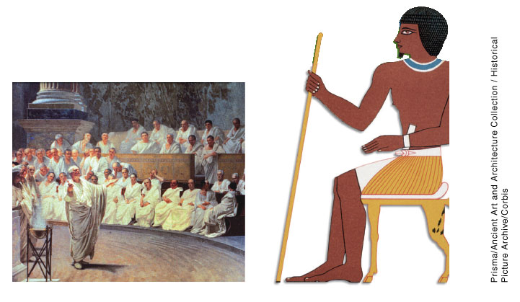

Rule by the Few
- Ancient Sparta, a military society, had two kings, a council of elders, and a group of officials who ran the day-to-day affairs. They were all members of the aristocracy, Sparta’s governing class of nobles and soldiers. For the Greeks, aristocracy meant government by those best suited to rule. Unlike neighboring Athens, Sparta never experienced tyranny.
- After the fall of the Roman Empire, the political system known as feudalism arose in Europe. In this system, the power lay with a military elite. The Greeks might have preferred to call it an oligarchy—government based on private interests rather than the interests of the whole society. Nobles traded land and labor for political and military service. Warfare dominated people’s lives.

Rule by the Many
- In 1789, the French Revolution abolished the monarchy and established a republic. This democracy, however, was unstable. France went through periods of empire, republic, and monarchy until the constitution of 1958 established the Fifth Republic. Today the government has a two-house parliament and a strong president who is directly elected. All citizens 18 and older, except for certain criminals, can vote.
- In 1961, South Africa left the British Commonwealth to become an independent republic. The movement to end apartheid, or racial separation, resulted in a new constitution in 1997. All citizens over age 18 can vote to elect members to a two-house Parliament. The lower house then elects a president as the nation’s head of state and chief executive.
Thinking Critically:
(a) Which of these three forms of government strikes you as the fairest? Why?

(b) Which do you think is most capable of defending a society from attack? Why?

c). Can you think of an example for each of these types of governments, either from history or from present day?
Rule by One: __________________________
Rule by Few: __________________________
Rule by Many: _________________________
Chapter 16, Sec 4 - Assignment and Instructions

- Read Chapter 16, Section 4
- Give a definition and explain the significance for each of the terms below.
- Answer the questions and Complete the Note Taking Study Guide

Chapter 16, Section 4 Vocabulary

- Elector:
Define:__________________________________________________________________________________________________________________________________________
Significance?
________________________________________________________________________________________________________________________________________________________________________________________________________________________

- Ferdinand:
Define:__________________________________________________________________________________________________________________________________________
Significance?
________________________________________________________________________________________________________________________________________________________________________________________________________________________
- Mercenary:
Define:__________________________________________________________________________________________________________________________________________
Significance?
________________________________________________________________________________________________________________________________________________
- Depopulation:
Define:__________________________________________________________________________________________________________________________________________
Significance?
________________________________________________________________________________________________________________________________________________________________________________________________________________________
- Peace of Westphalia:
Define:__________________________________________________________________________________________________________________________________________
Significance?
________________________________________________________________________________________________________________________________________________________________________________________________________________________
- Maria Theresa:
Define:__________________________________________________________________________________________________________________________________________
Significance?
________________________________________________________________________________________________________________________________________________________________________________________________________________________

- War of the Austrian Succession:
Define:__________________________________________________________________________________________________________________________________________
Significance?
________________________________________________________________________________________________________________________________________________
- Frederick II:
Define:__________________________________________________________________________________________________________________________________________
Significance?
________________________________________________________________________________________________________________________________________________
________________________________________________________________________
Questions:
- What were the causes and results of the Thirty Years’ War?
Causes | Results

- What caused the War of the Austrian Succession?
________________________________________________________________________________________________________________________________________________
________________________________________________________________________________________________________________________________________________
- How did European Nations Maintain a balance of power?
________________________________________________________________________
________________________________________________________________________________________________________________________________________________________________________________________________________________________
________________________________________________________________________

