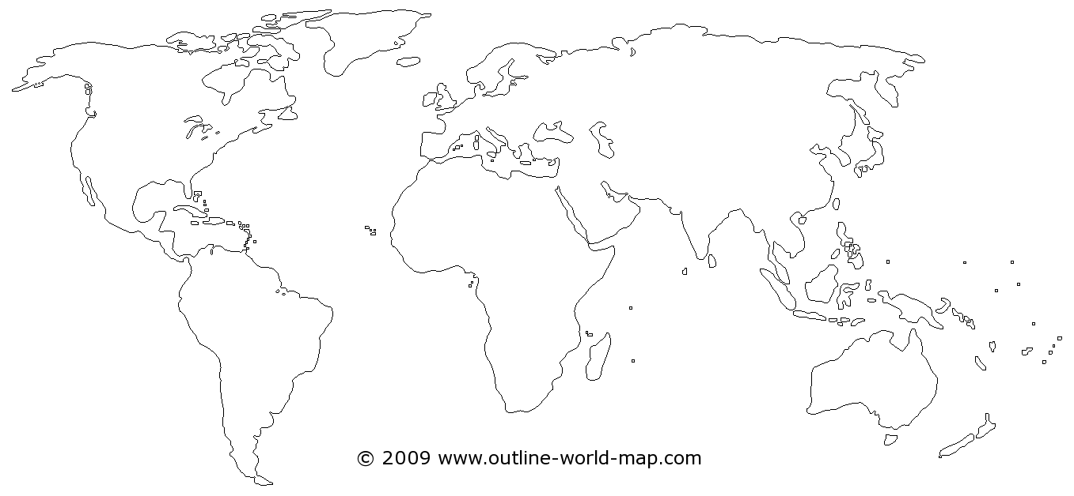

**Geographic Review!** Locate and label the following places: Brazil, The West Indies, Spain, Great Britain, France, The Strait of Magellan, Cape of Good Hope, India, China, The British colonies in North America, New France, the Middle Passage



**Explorer Review:** Match the Person with the continent that they are most associated

1. Pilgrims 9. Prince Henry the Navigator
2. Pizarro 10. Columbus
3. Amerigo Vespucci 11. King Affonso I
4. Henry Hudson 12. Cortes
5. Da Gama 13. De Las Casas
6. Charles V 14. Olaudah Equiano
7. Cartier 15. Dias
8. Qinalong 16. Moctezuma