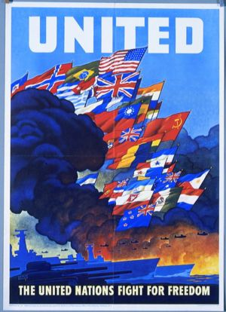
World War II (1939 – 1945)
Description:
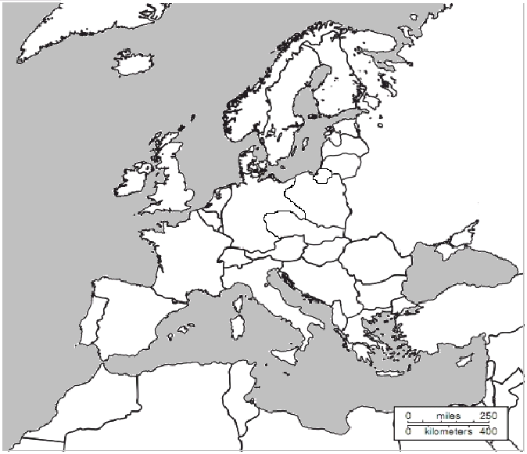
Our last unit will cover the turmoil of World War II and the post-war years. In 1939 the world would once again plunge into a global conflict and quickly become the deadliest military war in history, killing over 60 million people total. World War II was a conflict that involved virtually every part of the world during the years 1939–45. The principal belligerents were the Axis powers—Germany, Italy, and Japan—and the Allies—France, Great Britain, the United States, the Soviet Union, and, to a lesser extent, China. The war was in many respects a continuation, after an uneasy 20-year hiatus, of the disputes left unsettled by World War I. The deaths incurred in World War II make it the bloodiest conflict, as well as the largest war, in history.
Key:
X Totalitarian Dictators
# Land Annexed by Hitler

Axis Powers or Axis
Controlled Land by 1942

Allied Powers

Tasks:
- Locate and label the following countries: Spain, France, Italy, Germany, the United Kingdom, Austria, Czechoslovakia, Poland, the Soviet Union, Yugoslavia, Libya, Belgium, and Hungary. Locate and label: Atlantic Ocean, Mediterranean Sea, Black Sea
- Locate and place an X on the countries that were ruled by totalitarian dictators at the start of World War II.
- Locate and place a # on the regions that Hitler annexed in defiance of Versailles: Sudetenland (western Czechoslovakia), Austria, and the Rhineland.

- Lightly shade any countries in the Axis Powers or regions that came under Axis power.

- Lightly shade any countries that were members of the Allied Powers.

- Locate the following battles: Normandy, El-Alamein, Salerno, The Bulge, Stalingrad.

Questions:
- What was the strip of land between East Prussia and the rest of Germany called? Why is that a good name for the region?

- On the eve of war in 1939, which countries were probably going to be the most likely targets of German and Italian attacks?

- What geographic/ tactical problems do you think the Allied powers faced in 1942?
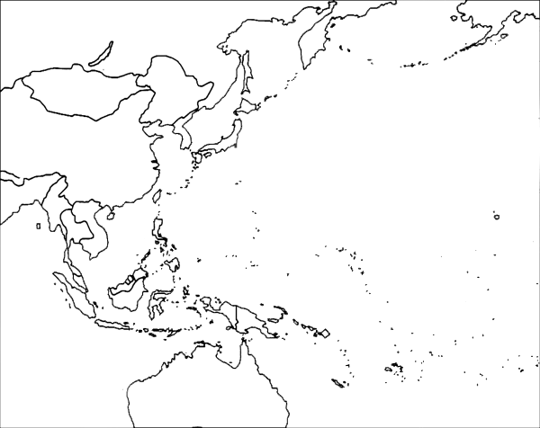
Key:

Tasks: use the map on page 949 in your textbook

- Locate and label the following countries: Australia, China, Manchuria, Mongolia, Soviet Union, Japan, Korea, Alaska, French Indochina, Philippine Islands,

- Locate the following battles: Battle of Midway, Iwo Jima, Okinawa and Batan. Locate the following cities: Hiroshima, and Nagasaki

- Lightly shade and outline the maximum extent of Japanese controlled area in 1942

Questions:
1. Describe the extent of Japanese control in 1942.

2. How did geography make it difficult for Japan to maintain control of its empire?

