Task: Listen to the Stuff you missed in History class Podcast: A Brief History of Redlining Part 1 and Part 2. While you listen answer the questions below
Stuff you Missed in History class – A Brief History of Redlining – Part 1
http://www.missedinhistory.com/podcasts/a-brief-history-of-redlining-part-1/
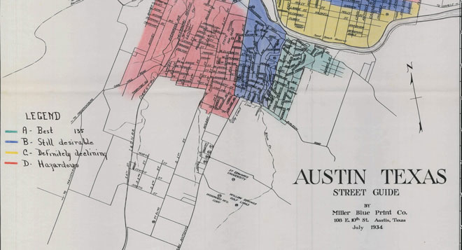
Episode Summary
Redlining is a word used to describe a lot of different patterns of economic discrimination. But during the Great Depression, real estate-related discrimination included systemized grading of neighborhoods based on the races that lived there.
Questions:
1. How were home mortgages designed prior to the Great Depression?

2. What was the HOLC and why was it established?

3. What was the City Survey Program?

4. How, historically, did area become segregated and what were some ways that local governments or neighborhoods attempted to maintain this segregation?

Blog/ Show notes: http://www.missedinhistory.com/blog/missed-in-history-redlining-part-1/
Stuff you Missed in History class – A Brief History of Redlining - Part 2:
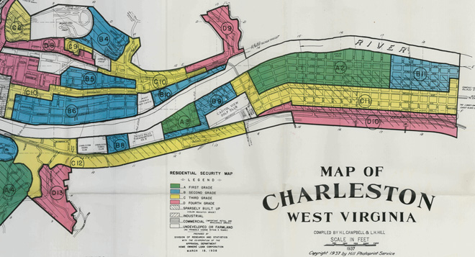
http://www.missedinhistory.com/podcasts/a-brief-history-of-redlining-part-2/
Episode Summary
Part two of this discussion of redlining explores the language that assessors used when making color-coded maps of neighborhoods in segregated cities. These maps were used to determine whether mortgage lending in those neighborhoods was desirable.
Questions:
1. Complete the following chart below by describing how the City Survey Program characterized the following color coded areas on the maps they created:
Grade A: Green | Grade B: Blue | Grade C: Yellow | Grade D: Red
2. How did redlining adversely impact the neighborhoods and their residents that were labeled as “Red” or hazardous investments?

3. What has the government done more recently to try to address redlining?

Blog/ Show notes: http://www.missedinhistory.com/blog/missed-in-history-redlining-part-2/
2. Listen to the brief podcast NPR: ‘There Goes the ‘Hood’: Gentrification in New York City. While you listen answer the questions below
NPR: ‘There Goes the ‘Hood’: Gentrification in New York City
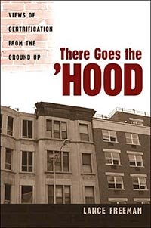
http://www.npr.org/templates/story/story.php?storyId=5569466
Is gentrification a bad word or a good influence? Lance Freeman, an assistant professor at Columbia University, talks with Farai Chideya about his new book exploring the gentrification of two predominately black neighborhoods in New York City — Manhattan's Harlem and Brooklyn's Clinton Hill.

Questions:
1. Define Gentrification:

2. What is Disinvestment?

3. List the Positive and Negative Aspects of Gentrifications:
Positive | Negative

Reflection: How did you like these three Podcasts? Did you find them informative? What would you like to see change about this assignment?

