{Topic #1 - Rise of Civilization}
- The pristine countryside and battle site of one of Rome’s greatest victories
- Professional guides to narrate the events of the battle and point out the important locations
- Reenactments of the battle itself using Roman and Greek actors
- The lovely towns of Pherae and Larissa in Thessaly

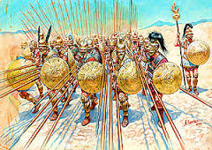
Picture 3

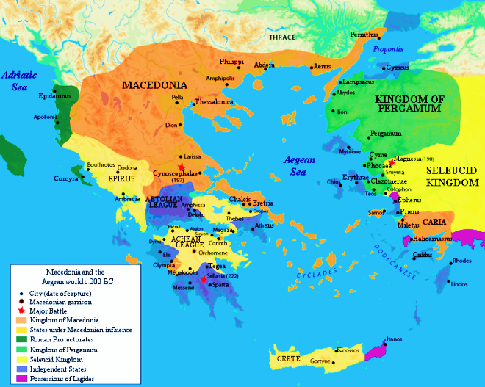
Map of Civilization
{title of Map}
Why Visit {Civilization}?
{“Quote about your Civilization from one of the sources. This quote should explain why your civilization is unique and/ or a desirable location to travel to. ”}
{Civilization} Site Tours
{This is a promotional section about your travel company. Be Creative and explain a little about your company. For example: We have offices all over the Empire and can easily help you to book a tour of one or even many of Rome’s triumphant victories or tragic defeats. Other battle site tours in Greece include…}
{City in your Civilization}
{Place of interest}

Ancient Mesopotamian Tours
{Civilization}
{Title}
{Short Description of Civilization}
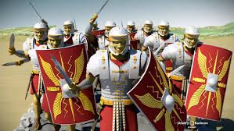
Picture 1
Picture 2

{Argument 1 – why should you travel to this civilization?}
Main Office: {Major City in your Civilization}

Topic #2:
- Rome suspiciously watched its neighbour across the sea. Philip V of Macedon sought supremacy over the Greeks, who requested help.
- No doubt confident after their defeat of Carthage in 202 BC, Rome now deemed it best to remove the Macedonian threat as soon as possible. The pleas by Greek city states for assistance were all the excuse they needed to intervene in 200 BC, beginning the Second Macedonian War.
- In 198 BC command passed into the hands of Titus Quinctius Flaminius. Had the previous Roman efforts led to nothing much, then things took a decisive turn with the arrival of Flaminius. He pushed on and finally managed to force a battle at the hills called Cynoscephalae.
Topic #3
Picture 4
- Both sides were roughly equally matched, mustering about 25'000 men each. But both sides employed different systems, the Romans used the legionary method which had brought them victory over Carthage, the Macedonians fought in the Greek phalanx, which had under Alexander the Great defeated the Persians.
- The armies closed on each other from either side of the chain of hills called Cynoscephalae. Both armies then made camp and spent the night on their side of the hills.
- In the morning both sides found the hills covered in dense mist, making visibility poor.
- The Macedonian king Philip was the first to send out a party to take control of the top of the hill chain in order to gain an advantage.
- When Flaminius also sent out a small force they found the Macedonian party already atop the pass between the two main hills. Clearly at a disadvantage the Romans suffered losses in the following skirmish and sent message for help.
Topic #4
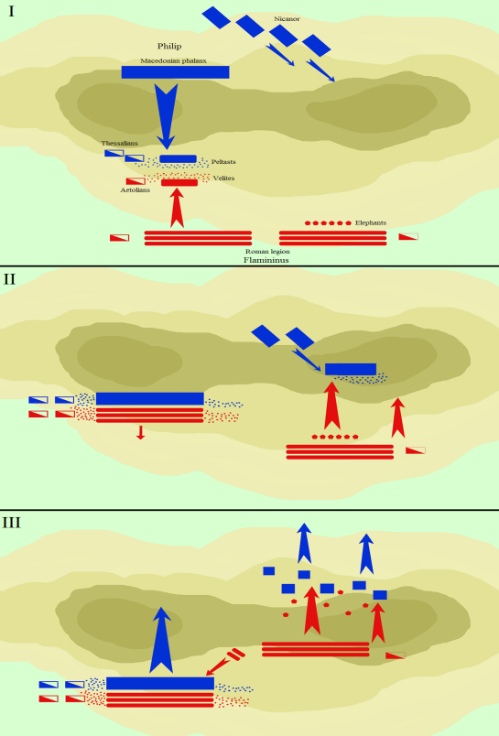
- The skirmishing had caused Philip to hold the advantage of the higher ground. It was the Macedonian center and right wing which held the heights, their left was still marching up the hill. This break in the Macedonian line was to prove a fatal flaw. With the Macedonian left nowhere to be seen, Flaminius ordered his right to stay at the bottom of the slope.
- As the Romans brought up their forces to meet the enemy at the pass, Philip simply ordered his phalanx to level their spears and attack. The phalanx being the evidently superior force in the contest so far, Flaminius needed to act fast, if his left was not simply to be crushed by Macedonians.
- He took control of his army's right and advanced rapidly, hoping to divert some of Philip's main force to the aid of the left wing. With elephants leading the way, the Roman troops rushed up the hill, trying to save the day. They met the Macedonian left which had only just reached the summit of the hill and was not yet in proper formation .
Conclusion
- 2-3 sentences on why someone should travel to your civilization.
- What makes your civilization unique and noteworthy?

