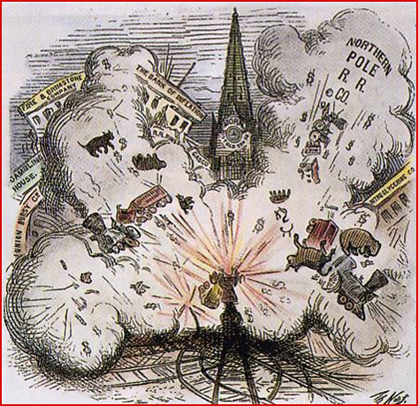
What was Reconstruction?
Reconstruction: the era between 1865- 1877, in which the federal government struggled with how to return the Confederate states to the Union, rebuild the South’s economy & protect the rights of former slaves
Life in the Southern States after the Civil War:
“A visitor to Charleston, South Carolina, wrote of ‘vacant houses, of widowed women, of rotting wharves, of deserted warehouses, of weed-wild gardens, of miles of grass-grown street.” Most of the South’s cities were in the same shape. And the countryside? ‘We had no cattle, hogs, sheep, or horses or anything else,” a Virginian wrote. “The barns were all burned, chimneys standing without houses and houses standing without roofs, or doors, or window.” Across the South everything seemed collapses and disordered. There was no government, no courts, no post office, no sheriffs, no police. Guerrilla bands looted at will. A generation of white Southern men was dead. Those who came home brought wounds with them. In 1866, the year after the war’s end, Mississippi spend one-fifth of its revenues on artificial arms and legs.
Key Questions during Reconstruction
- How do we bring the South back into the Union?
- How do we rebuild the South after its destruction during the war?
- How do we integrate and protect newly emancipated freedmen?
- What branch of government should control the process of Reconstruction?
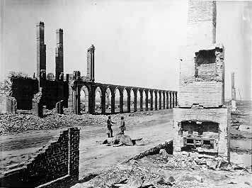
- Joy Hakim, Reconstructing America: A History of US
“War is hell,” said General Sherman. This is the railroad depot in Charleston, South Caroline, after Sherman’s troops passed by.

