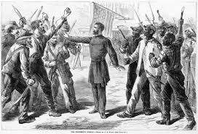
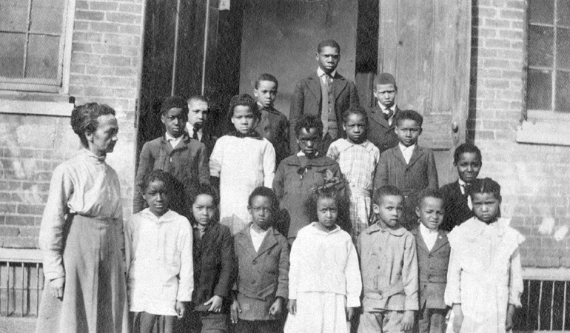
1. Many teachers who went south to instruct former slaves felt as if they were in a foreign land. One teacher in Georgia said, “Our work is just as much missionary work as if we were in India or China.”
2. In this drawing a Union office stands between angry whites and angry blacks. The artist was trying to show that soldiers were needed to keep peace in the former Confederacy. Congress did send Northern troops south to maintain order and protect the rights of the freed persons. Soldiers rule is called ‘martial law.” (See chapter 5 for more about this.)

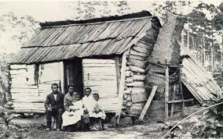

3. “It seemed like it took a long time for freedom to come. Everything just kept on like it was. We heard that lots of claves was getting land and some mules to set up for themselves. I never knowned any what got land or mules nor nothing.”
- Millie Freeman (former slave)

The Freedmen's Bureau, was a U.S. federal government agency that aided distressed freedmen (freed slaves) during the Reconstruction era. The Freedmen's Bureau Bill, which established the Freedmen's Bureau on March 3, 1865, was initiated by President Abraham Lincoln and was intended to last for one year after the end of the Civil War. The Freedmen's Bureau was an important agency of the early Reconstruction, assisting freedmen (freed ex-slaves) in the South. the Bureaus powers were expanded to help find lost families for African Americans and teach them to read and write so they could better do so themselves. By 1869, the Bureau had lost most of its funding and as a result been forced to cut much of its staff. By 1870 the Bureau had been considerably weakened due to the rise of Ku Klux Klan violence in the South.

