Human Geography

Ms. Ramm
Room 205
lramm@rsd17.org

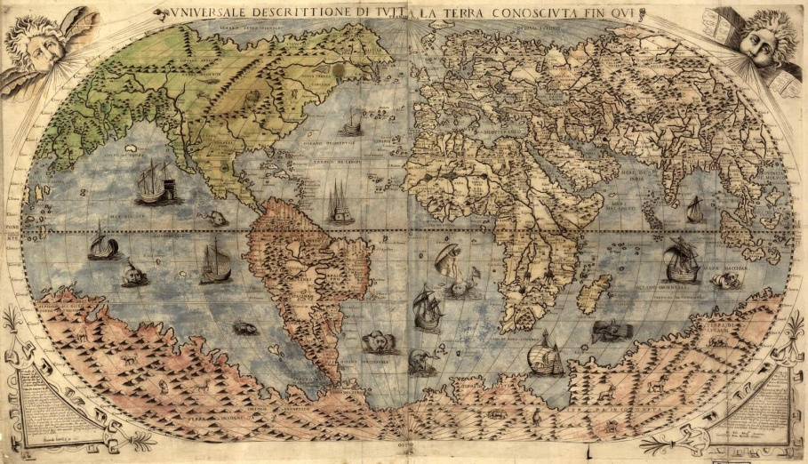
“Geography doesn't simply begin and end with maps showing the location of all the countries of the world. In fact, such maps don't necessarily tell us much. No -- geography poses fascinating questions about who we are and how we got to be that way, and then provides clues to the answers. It is impossible to understand history, international politics, the world economy, religions, philosophy, or 'patterns of culture' without taking geography into account.”
– Kenneth C. Davis

General Overview
Human Geography focuses on understanding spatial relations or the why of where. Why is something where it is and what connections can you make regarding its location? This course covers all social and natural phenomena and includes anything that can be mapped in order to gain a better understanding of these relationships. Human geography's purpose is to make sense of the surface of the earth using spatial (locational), environmental, multi-disciplinary and integrative perspectives.

AP Human Geography is a comprehensive class that covers the seven following units:

- Nature and Perspectives of Human Geography
- Population
- Culture
- Political
- Agriculture/Rural Land Use
- Economic/Industry
- Urban Land Use

Each of these units is interrelated and the AP exam will often ask you to analyze or draw connections between these topics. As the exam will require you to connect these units together we will do the same in class. Throughout the course of each unit there will be homework assignments, quizzes, class discussions, computer labs, and at the end of each unit a comprehensive (this means, for example, that questions on an exam in April will include material from September) exam that will follow the format of the AP exam that is given in May*. Unit exams will also follow the AP exam format and will include multiple choice questions constructed (free) response question(s). (I will provide you with a separate handout explaining the criteria that will be looked at by scorers with regard to your constructed responses.)

Throughout the course there will be plentiful opportunities for discussion, which I would encourage you to actively participate in. Many of these discussions will be geographic and spatial in nature but a significant portion of our discussions will be related to current events Please feel free to being in articles that you feel will add to our study and will be worthwhile for the class to hear about and discuss. You can use this information when you are creating your own maps, looking at case studies, writing constructed response questions and completing research projects.

Maps will be an essential feature of this course and students will need to know world regions and world countries in all regions. We will be examining different types of maps and analyzing what the maps might lack or direct our perspective in some way. Throughout the course we will have map quizzes and to learn more about the different regions of the world that we will be studying.

The textbook we will be using is The Cultural Landscape: An Introduction to Human Geography by James Rubenstein. You WILL have to read the textbook and take notes. I will also give you a number of additional readings that are required and which will help supplement your textbook.

*This year’s APHG exam will be Tuesday, May 14th, 2019
Afternoon Test

Materials Needed
A loose-leaf notebook with three rings is suggested for this course. You may need more than one as this is a HUGE topic! Likewise, I suggest you put tab dividers in this notebook to separate your notes, key terms, class handouts and the like into the seven units of study that we will be covering.

Study Groups
I suggest that you form a study group with 2-4 other students, as you would in any college class. This will help you be successful on quizzes, tests, and prepping for the AP exam. My philosophy with regard to AP courses is to prepare you to the best of my ability but also to get you ready for the rigors and responsibility you will encounter in your college and careers. Finally, always know that I am readily available to help you with any problems you may encounter in this class or any questions you may have.

Quizlet - https://quizlet.com/class/1013718/
A Quizlet page has been created for this class and you are encouraged to create a quizlet account and join the class to make use of the study materials. Quizlet includes sets of vocabulary that can be modified or added to, matching games, self-tests and flash cards that can be printed or used on the app. To join the class, enter the link above or search for the class AP Human Geography HKHS, or the member name of MsRamm.

Class Webpage - http://lramm.rsd17.org/ap-human-geography.html
A webpage has been created for the class that contains varied content including: a calendar of all of the homework assignments, study materials, argumentative essays, class activities, a list of unit objectives, and research materials. We will routinely use this website in class and students will also be asked to check the site for homework.

Grading Policy:

30% - Quizzes/ Free Responses
50 % - Tests/ Essays/ Labs
20% - Classwork/ Homework/ Participation

Homework Policy: Homework is due the day after it has been assigned. If you are absent the missed assignments are due one day from the day you return unless you have previously spoken to me. Students will only receive partial credit for late assignments. If you know you are going to be absent or are ill for extended periods of time, please come see me to create a schedule for making up work.

Attendance – (Refer to the Student Handbook for the full attendance policy) Please be on time and prepared for class. Tardiness will not be accepted and it is important not to miss class.
Cheating and Honor Code – (Refer to the Student Handbook for full policy) Plagiarism is unacceptable and any violation of the honor code will be persecuted. Plagiarism is both the intentional and unintentional use of another’s ideas, words, phrases, metaphors, and structures without giving proper credit. This makes plagiarism a question of fact not intent. To avoid plagiarism make sure that you take careful notes during the writing/ research process and develop a habit of identifying (or citing) the authors/ sources that you are indebted to.

AP TEST Structure
To earn credit for this class all students are required to take the AP test in MAY
Section 1 – 75 questions (60 minutes) 50%
Section 2 – 3 Essays (75 minutes) 50%
- - - - - - - - - - - - - - - - - - - - - - - - - - - - - - - - - - - - - - - - - - - - - - - - - - - - - - - - - - - - - -

AP HUGE!

HOMEWORK AND CLASSROOM POLICIES
Welcome to AP HUGE! Below you will find a list of classroom expectations and policies for this course.

Rules of the Classroom –
- Treat others in the class as you would like to be treated and respect their ideas by listening and paying attention.

- Be prepared for class by bringing a writing utensil, your textbook, notebook, and any due homework or other assignments.

- Do NOT use cellular devices, or electronics unless asked to do so (these will be confiscated if they are being used inappropriately)

- Be on time to class and have a pass if you are going to be late.

- Food or drink will be allowed until it makes a mess, becomes a distraction or is left in class.

- Homework is due the day after it has been assigned. If you have missed class your homework must be turned in the next time you are in class. Students can only receive partial credit for late work.

- If you are absent, get any assignments/notes from another student or talk with me directly. All homework assignments will be posted on my website as well.

- Plagiarism in any form will not be tolerated.

- Feel free to stop by during free time or after school to ask any questions about the class that you might have.
- Behavioral Agreement:
a). Students will be verbally warned for minor transgressions of any classroom guidelines
b). If student’s behavior does not change he or she will be assigned a ½ lunch detention
  - If you are assigned a ½ lunch detention you must report to my room the next lunch period
  - If you fail to come to the ½ lunch detention you will be given a full lunch detention for the next lunch period
  - If you fail to come to the full lunch detention you will be referred to the office, you will be assigned an after school detention and your parents will be contacted.
c). Any serious behavioral infractions will receive an after school detention, referral to the office and your parents will be contacted.
- If you have problems meeting class expectations please see me to discuss

If you have any questions please feel free to either call at (860) 345-8541 x205 or email me at lramm@rsd17.org. (email is preferable). Please keep this syllabus in your class binder throughout the year.
- - - - - - - - - - - - - - - - - - - - - - - - - - - - - - - - - - - - - - - - - - - - - - - - - - - - - - - - - - - - - -

Student Accountability/Syllabus Form
In order to create a database of contact information and for me to ensure that both you and your child has read and understood the class guidelines, I am asking for each parent to email me or complete the form at the bottom of this page with a small amount of information. I would appreciate it you could please email me the following information at lramm@rsd17.org or return this form by September 8th. If you have any questions or concerns throughout the year, please feel free to email me.

I have read and understood Ms. Ramm’s class policies and expectation. I agree to work to the standard that has been set.
Student’s Name__________________________________ Signature____________________________________

Parent/Guardian(s)_______________________________ Signature____________________________________

- Home Phone*_________________________ Work and/or Cell Phone___________________________

- Email Address*: _______________________________________________________________________
*(Please select which is your preferred method of communication)
Any concerns or additional information

