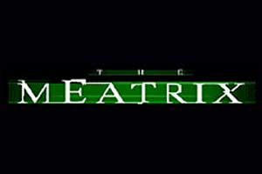
Unit 5: Agriculture and Rural Land Use
*these videos are biased against agri-business practices and has a particular viewpoint that they are attempting to promote. Your job is to identify the main ideas
The Meatrix
What are the main points of the presentation?
And what do you know/ what is your opinion about each?
Video | Main Points | Opinion?
1.
2.
3.
How are these videos trying to influence the viewer? Do you think they are effective?

What are some arguments you could make against their main ideas?

