Webbly 101 – How to embed your Google Calendar into your Weebly Page
*You will need a Google account in order to add a calendar. Your school email should be your account email and you can create a password
Steps:
1. Access your Google Account: Log into your google account and locate the calendar icon. Select the icon and you will be able to view the calendar.
_____________________________________________________________________________________
2. Create calendar(s) for a class
i. Select the “My Calendars” table.
ii. Select the “Create new calendar” tab.
iii. Give the calendar a name and fill in any other details that you would like (Description, location, etc.)
*Make sure you make the calendar public. This will allow the changes that you make to the calendar viewable for your students. Without this step your calendar will not update. You can go back and do this later through the “Calendar Settings” options if you already have a calendar created that you would like to share.
iv. Select the create calendar icon to finalize the creation of your calendar.
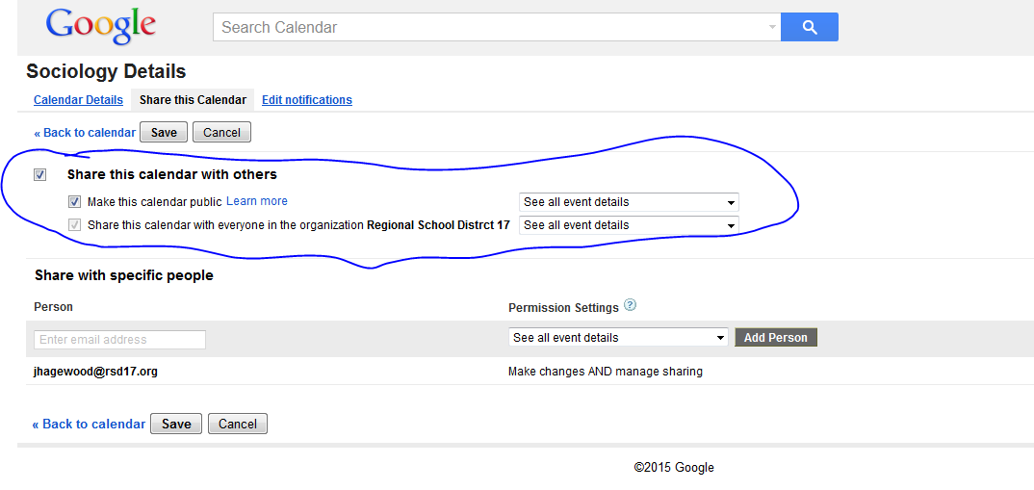
3. Embedding Calendar into Weebly
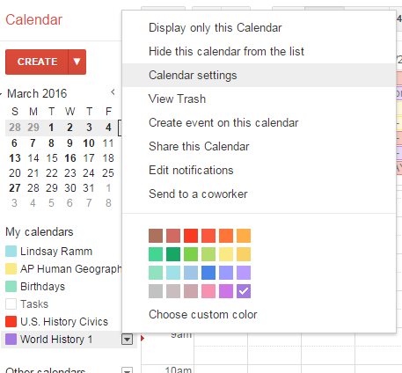
i. In the calendar list on the left hand side of your google calendar page, click the down-arrow next to your new calendar and select the “Calendar Settings” option.

*This will bring you back to the calendar information page that you were at when creating your new calendar.
ii. Then select the “Calendar Details” tab and go to the “Embed this Calendar” section.
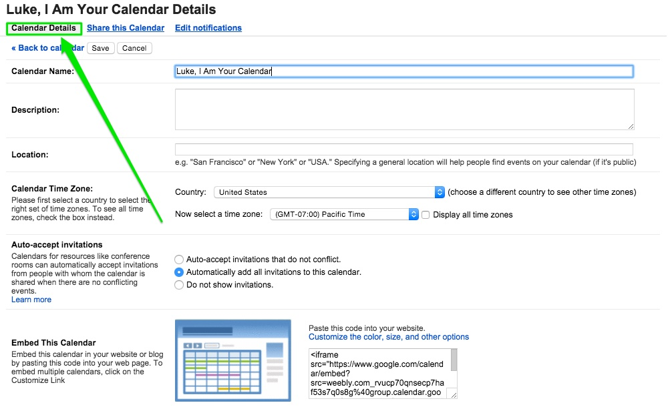
iii. Highlight and copy the provided embed code. This is what you’ll use to add the calendar to your site.
*you can also use the “Customize” link above the code to make changes to the look and size of the calendar.

iv. Open Weebly editor. Drag the Custom HTML element to the page you would like to place your calendar on
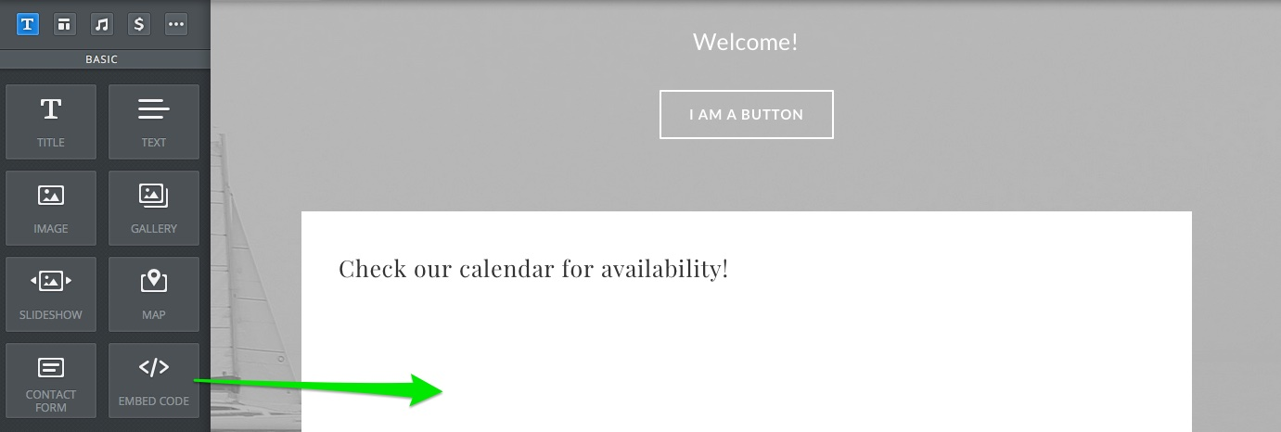
v. Paste the calendar embed code into the element
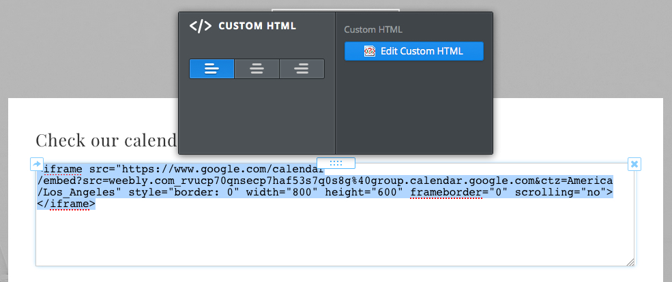

vi. Click out of the element to see your calendar and then click the “Publish” button. Your calendar will now appear on your live site.
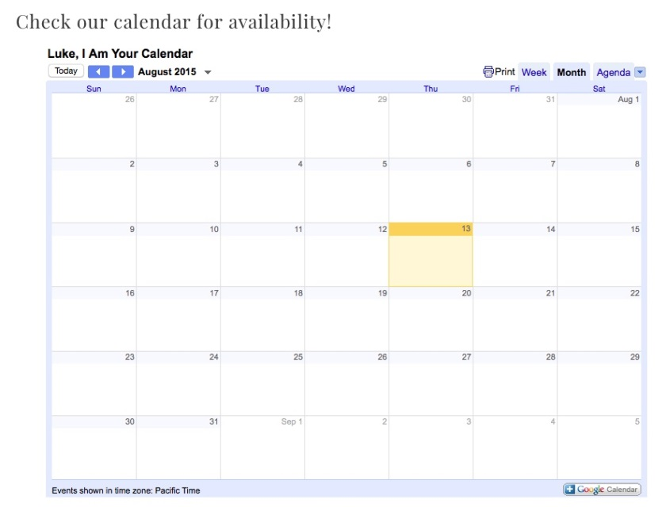
4. Making changes to your calendar
*When you add an assignment in google calendars the calendar on Weebly will automatically reflect that changes that you made in google
**Do we want to put directions for adding assignments to the google calendar? It may ease any trepidation about Google Calendar for the staff members.

